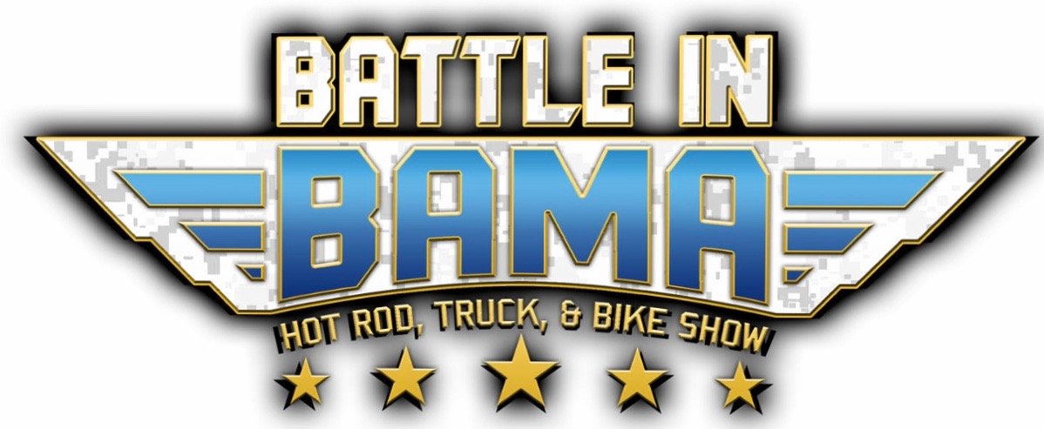
May 5th – 7th, 2023
Self-Contained Food Vendor Booth Space
(NO REFUNDS - This is a rain or shine event)

Company Name: Contact Person:

Address:

Phone: Email:

Names of owners/employees working the booth during the event?

Wristbands will be issued for the owners/employees listed above that will be working the booth, please ensure that they are worn all weekend long to prevent any issues when entering the gate. Additional wristbands will not be given, they will need to be purchased at the gate.

Payment: We will not accept any applications without payment. Once payment is received your vendor space will be guaranteed. Make all checks payable to: Battle In Bama. We do not accept credit cards. Any checks returned due to insufficient funds will be assessed a $35.00 surcharge, plus any additional fees incurred.

Beverage Policy: Food vendors may sell non-alcoholic beverages only from their booth.

Grease: No grease or gray water is to be poured onto the ground or down any drains. Anyone found doing this will be politely asked to leave the event and your payment will be forfeited. You will be responsible for any and all environmental cleanup costs and subject to prosecution by city and/or state officials.

Trash: Vendors are responsible to collect and properly bag trash within your designated space. Battle In Bama staff will collect properly bagged trash from outside your designated vendor space.

Water: Water may or may not be easily accessible. Please bring appropriate hoses, hose connections, and transport buckets.

I agree to abide by the rules stated. I understand that all promotion of my items must take place within the confines of my designated vendor space. I understand that there are no refunds or rain checks due to inclement weather. Battle In Bama, LLC, reserves the right to refuse vendor space if these guidelines are not upheld. Battle In Bama, LLC, will not assume or pay taxes for items sold at Battle In Bama.

Print Name: Signature: Date:

Please remit application and payment to:
Battle In Bama
11390 Saint Ives Court
Daphne, AL 36526
crowley@battleinbama.net

WAIVER AND RELEASE OF LIABILITY
FOR
BATTLE IN BAMA, LLC,
AN ALABAMA LIMITED LIABILITY COMPANY

In consideration of the risk of injury or damages while participating as a "VENDOR" in the CAR, TRUCK, AND BIKE Show hosted by BATTLE IN BAMA, LLC, AN ALABAMA LIMITED LIABILITY COMPANY, (the "Activity"), and as consideration for the right to participate as a Vendor in the Activity, I hereby, for myself, knowingly and voluntarily enter into this waiver and release of liability and hereby waive any and all rights, claims or causes of action of any kind whatsoever arising out of my participation as a Vendor in the Activity, and do hereby release and forever discharge Battle In Bama, LLC, AN ALABAMA LIMITED LIABILITY COMPANY, their affiliates, managers, members, agents, attorneys, staff, volunteers, heirs, representatives, predecessors, successors, and assigns, for any physical injury, including but not limited to illness, paralysis, death, damages, economical, or emotional loss, or any monetary damages to materials, equipment, tools, resources, food and products, that I may suffer as a direct result of my participation in the aforementioned Activity.

I AM VOULUNTARILY PARTICIPATING IN THE AFOREMENTIONED ACTIVITY AND I AM PARTICIPATING IN THE ACTIVITY ENTIRELY AT MY OWN RISK. I AM AWARE OF THE RISKS ASSOCIATED WITH TRAVELING TO AND FROM, AS WELL AS PARTICIPATING IN THIS ACTIVITY, WHICH MAY INCLUDE, BUT ARE NOT LIMITED TO, PHYSICAL INJURY, PAID, SUFFERING, ILLNESS, DISFIGUREMENT, TEMPORARY OR PERMANENT DISABILITY, ECONOMIC OR RMOTIONAL LOSS, AND DAMAGE TO ANY EQUIPMENT OR MATERIALS NONETHELESS, I ASSUME ALL RELATED RISKS, BOTH KNOWN OR UNKNOWN TO ME, OF MY PARTICIPATION AS A VENDOR IN THIS ACTIVITY.

I agree to idemnify and hold harmless BATTLE IN BAMA, LLC, AN ALABAMA LIMITED LIABILITY COMPANY, against any and all claims, suits or actions of any kind whatsoever for liability, damages, compensation or otherwise brought by me or anyone on my behalf, including attorney's fees and any related costs, if litigation arises pursuant to any claims made by me or by anyone else acting on my behalf.

I acknowledge that BATTLE IN BAMA, LLC, AN ALABAMA LIMITED LIABILITY COMPANY, is not responsible for any taxes, fines, licenses, or expense of each vendor or business. Each vendor is responsible for their own materials, equipment, tools, resources, food, licenses, and products. Each vendor is responsible for collecting and properly disposing of all trash within the designated space assigned to you.

I acknowledge that BATTLE IN BAMA, LLC, AN ALABAMA LIMITED LIABILITY COMPANY, if not responsible for any and all environmental cleanup, including all grease and contaminated water disposal and the costs, fines, or expenses regarding same. I acknowledge that grease and contaminated water shall not be disposed of on the ground or down any sewage drains.

I acknowledge that BATTLE IN BAMA, LLC, AN ALABAMA LIMITED LIABILITY COMPANY, and their managers, members, volunteers, representatives and agents are not responsible for any errors, omissions, acts or failures to act of any party, including myself or my agents, or entity conducting this specific event or activity on behalf of BATTLE IN BAMA, LLC, AN ALABAMA LIMITED LIABILITY COMPANY.

I ACKNOWLEDGE THAT I HAVE CAREFULLY READ THIS "WAIVER AND RELEASE" AND FULLY UNDERSTAND THAT IT IS A RELEASE OF LIABILITY. I EXPRESSLY AGREE TO RELEASE AND DISCHARGE BATTLE IN BAMA, LLC, AN ALABAMA LIMITED LIABILITY COMPANY, AND ALL OF ITS AFFILIATES, MANAGERS, MEMBERS, AGENTS, ATTORNEYS, STAFF, VOLUNTEERS, HEIRS, REPRESENTATIVES, PREDECESSORS, SUCCESSORS AND ASSIGNS, FROM ANY AND ALL CLAIMS OR CAUSES OF ACTION AND I AGREE TO VOLUNTARILY GIVE UP OR WAIVE ANY RIGHT THAT I OTHERWISE HAVE TO BRING A LEGAL ACTION AGAINST BATTLE IN BAMA, LLC, AN ALABAMA LIMITED LIABILITY COMPANY, FOR PERSONAL INJURY OR PROPERY DAMAGE.

In the event that any damage to equipment of facilities occurs as a result of my willful actions, neglect or recklessness, I acknowledge and agree to be held liable for any and all costs associated with any actions of neglect or recklessness.

I CERTIFY THAT I HAVE READ THIS DOCUMENT AND I FULLY UNDERSTAND ITS CONTENT. I AM AWARE THAT THIS IS A RELEASE OF LIABILITY AND A CONTRACT.

Business Name:

Print Name: Title:

Signature: Date:

